# Location Labelling

# TWL Bartender procedures

|  |  |
| --- | --- |
| Prepared by: | Craig McLintock |
| Version: | 2.0 |
| Date: | 27.02.2015 |
| Stakeholders: | Steve Dickson, Keith Purcell, Duncan Phillips, Stuart McCombe, Richard Hutton |

Contents

Location Labelling 1

TWL Bartender procedures 1

1. background 3

2. Select Label Template 4

3. Prepare List of Locations to Print 4

4. Mass Print of Location Labels 5

5. Troubleshooting 8

6. Appendix A - Sample Labels 12

### background

The eMerge project introduces the capability to integrate RF barcoding functionality for the primary warehouse controls around the following activities:

* Inward goods receipting and warehouse location control.
* Sales order picking for outward delivery.
* Stock control counting.

This document relates purely to the procedures for the production of barcode labels for the warehouse locations and bins.

To enable barcoding of Warehouse Bin Locations the following have been setup in P Drive (P:\Transport Wholesale Limited\Distribution\Barcoding):

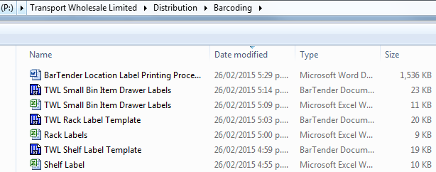

This folder contains:

* Instructions (this document)
* Small Bin Bartender and data template.
  1. Small Bins are generally the blue bins in the small binning area which have a part number and description. Going forward we will replace this lable with another with the NAXT Barcode as well as Id, Description, Quantity and Barcode.
  2. Navision contains some barcodes currently, but not a complete data set.
* Rack Bartender and data template
  1. Racks require a single 300 * 60mm label per beam identifying the unique location code
* Shelf Bartender and data template
  1. Shelves are in the Small Binning area and require a single 60 * 20mm label pershelf indetifying a unique location code.

In each case the Bartender File (Blue) has the layout of the label and prints what ever is in the associated spreadsheet.

Prerequisites:

* Bartender Setup (performed by helpdesk)
* Ability to print to your label printer (setup by helpdesk)
* Access to P:\Transport Wholesale Limited\Distribution\Barcoding
* Access to sharepoint path eMerge Project > Change Management > Barcoding > Bin Location Codes > TWL Warehouse >TWL Bin Mapping v06.xlsx

### Select Label Template

There are a number of label templates to allow you to print the appropriate sized labels:

|  |  |  |  |  |
| --- | --- | --- | --- | --- |
| **Label Name** | **Width**  **(mm)** | **Height**  **(mm)** | **Data Template to be populated** | **Bartender File to Open** |
| TWL Rack Label | 301 | 60 | P:\Transport Wholesale Limited\Distribution\Barcoding\Rack Labels.xlsx | P:\Transport Wholesale Limited\Distribution\Barcoding\ TWL Rack Label Template.btw |
| TWL Shelf Label | 65 | 20 | P:\Transport Wholesale Limited\Distribution\Barcoding\Shelf Label.xlsx | P:\Transport Wholesale Limited\Distribution\Barcoding\TWL Shelf Label Template.btw |
| TWL Small Bin Item Labels | 65 | 20 | P:\Transport Wholesale Limited\Distribution\Barcoding\TWL Small Bin Item Drawer Labels.xlsx | P:\Transport Wholesale Limited\Distribution\Barcoding\TWL Small Bin Item Drawer Labels.btw |

New templates can be prepared if you have specific requirements to fit your racking or printer.

See Appendix A for sample label output

### Prepare List of Locations to Print

The next step is to prepare a list of Locations to print.

A master sheet mapping the existing TWL Locations to the new locations has been done an id stored on sharepoint the path is eMerge Project > Change Management > Barcoding > Bin Location Codes > TWL Warehouse >TWL Bin Mapping v06.xlsx

Shortcut here: <https://emerge.goughgroup.co.nz/Shared%20Documents/Change%20Management/Barcoding/Bin%20Location%20Codes/TWL%20Warehouse/TWL%20Bin%20Mapping%20v06.xlsx>

The format of the file is:

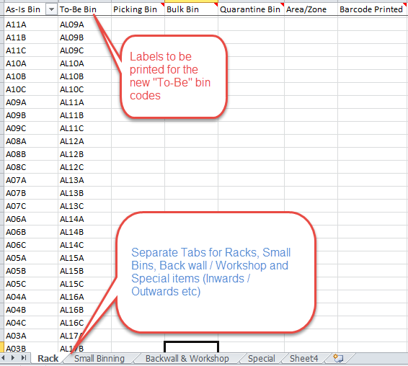

The best approach is to copy a Bay or goup of Bays from the above mapping spreadsheet and paste into the label printing templates, examples below.

Sample Templates:

|  |  |  |
| --- | --- | --- |
| **Rack** | **Shelf** | **Bin Item labels** |
| C:\Users\craigmc\AppData\Local\Temp\SNAGHTML3ab52c.PNG |  |  |

Enter in all Locations within the relevant section that require a Location barcode.

Ensure you list them in the order you want them to print out.

Note: Bin Item Labels will need to be created based on individual items and sourcing it’s barcode.

Remember to save the file.

### Mass Print of Location Labels

It is recommended to do a section at a time, after copying the To-Be bins from the mapping spreadsheet, described above and pasting into the relevant printing template.

After you have filled in the spreadsheet template, follow these steps to print your location barcode labels:

1. Open the Label Template (above) that you require

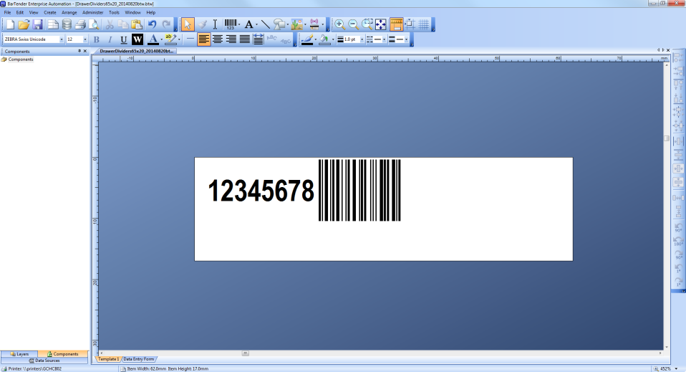

1. To Print the Barcodes choose the Print Icon or go File menu -> Print.

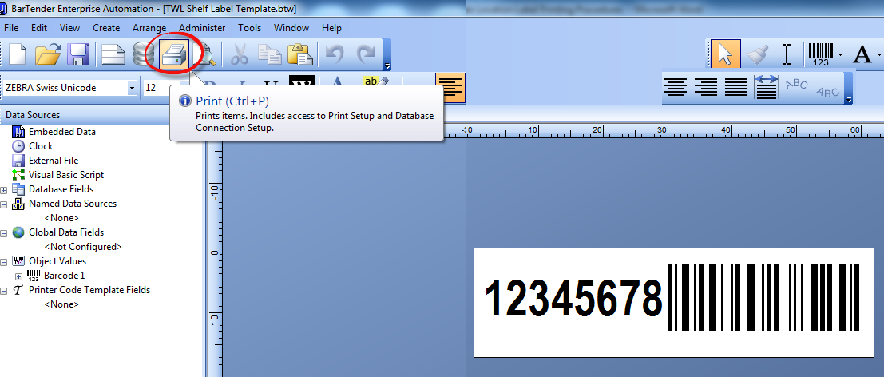

1. The print box provides some useful options.

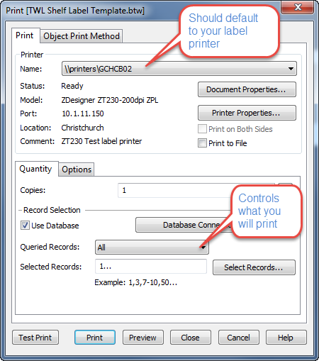

The “Queried Records” option allows you to choose:

**All** – will print a lable for every record in the template to print

**First Record Only** – will print 1 label so you can check your setup

**Selected** - if choosing this option then you need to click the “Select Records” button to select which records you want:

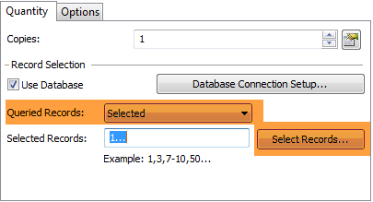

Here you can tick or untick records to control what you print:

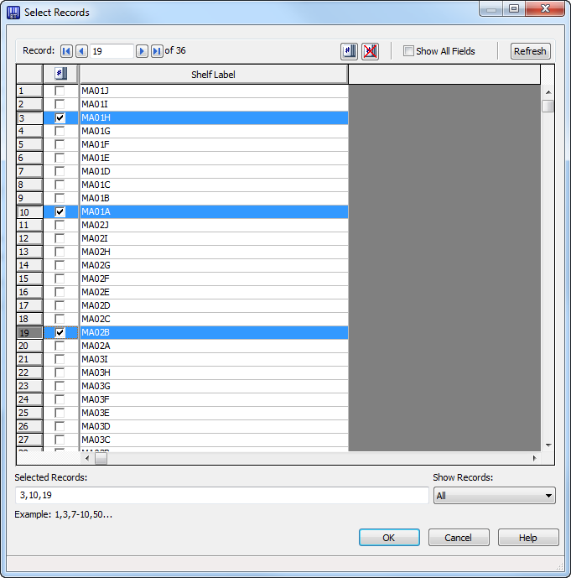

### Troubleshooting

Generally problems you will strike will be with Bartender having a problem reading the data from the spreadsheet. Follow the steps below to reconnect the source data:

1. Click on the “Database Connection Setup” icon

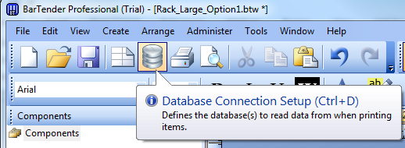

1. Click Add (Note once you’ve set this up once your template will be displayed)

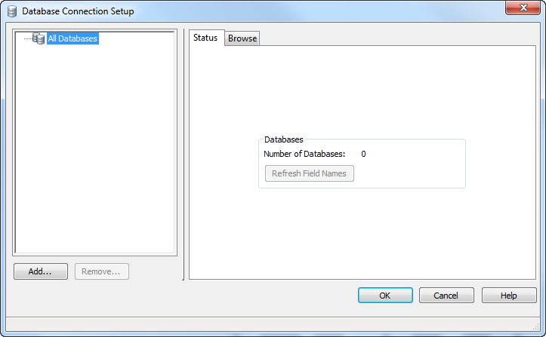

1. The wizard will start, click next

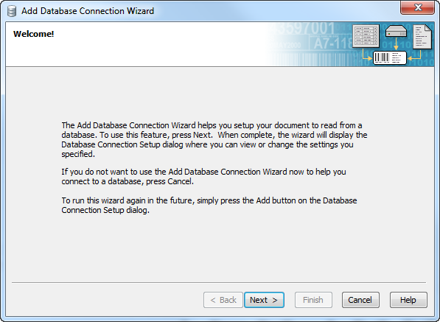

1. Select “Microsoft Excel”

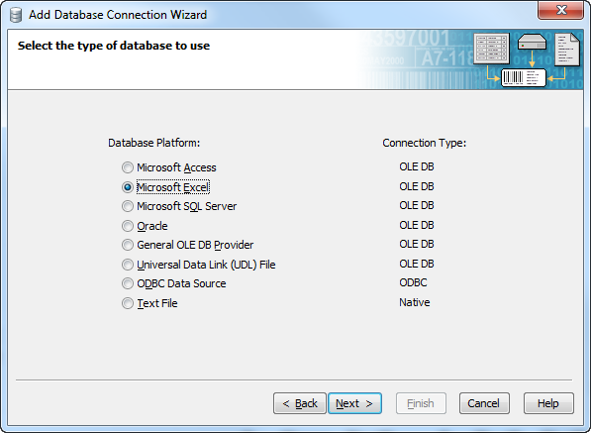

1. Browse to select your template, once selected click “Test Connection” to confirm all is ok.

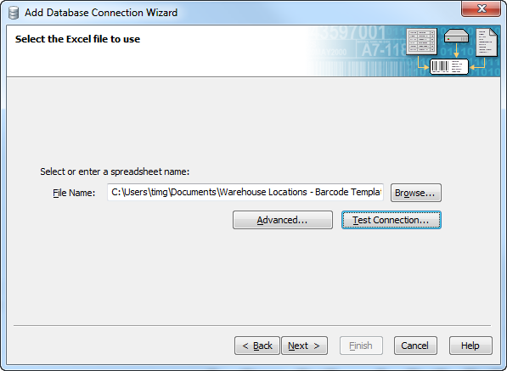

1. Select the Worksheet that you want to use, for example if you want to print Drawer labels then select the Drawers worksheet. Click “Add” to move it to the right panel. Then click Next.

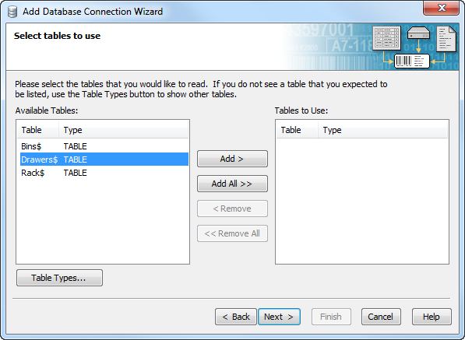

1. On the next screen just click Finish. You will then have all the locations available to print.

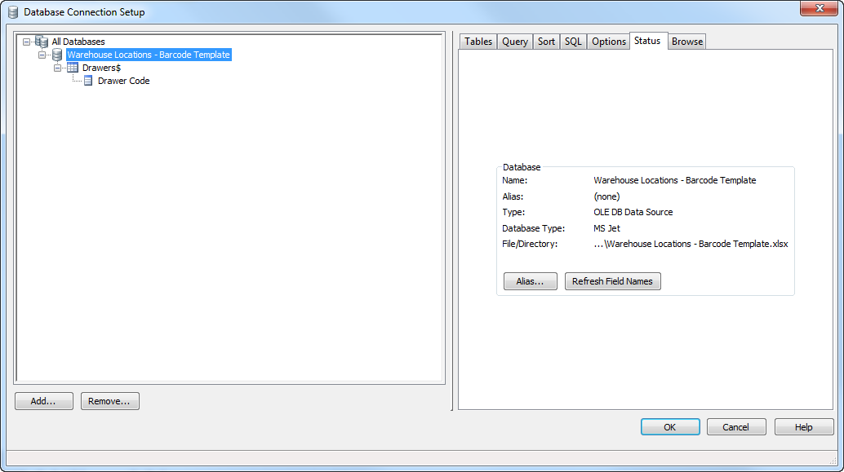

1. The final step is to tell Bartender what to print on the label. Double click on the barcode, then in the prompt box click on the line that says Field:…. (at bottom of list).

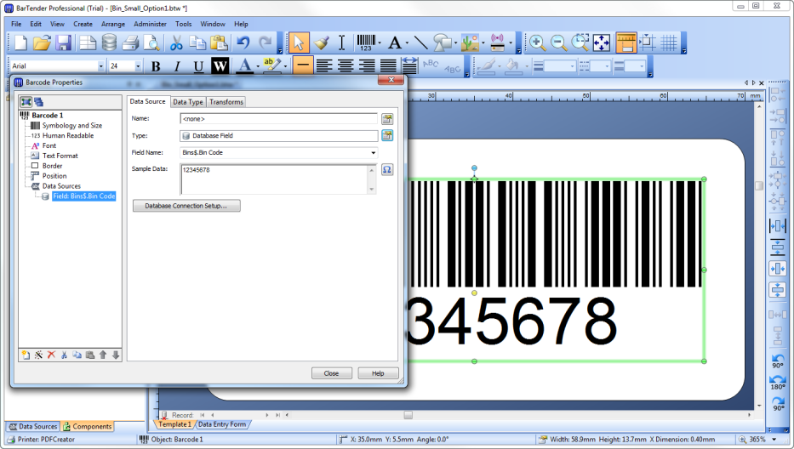

Ensure the Type field is set to “Database Field”

In the Field Name dropdown select the relevant list:

* If printing Racks then select Rack Labels
* If printing Shelf then select Shelf
* If printing Drawer then select Code
* If printing Divider then select Drawer Divider
* If printing Bin then select Part, Description, Unit of Measure and Barcode (need to do each one from the correct field)

1. To Print the Barcodes go File -> Print. If you wish to print more that one label for each location change the number in the copies box, however please note this will not collate the labels.

Otherwise just select Print.

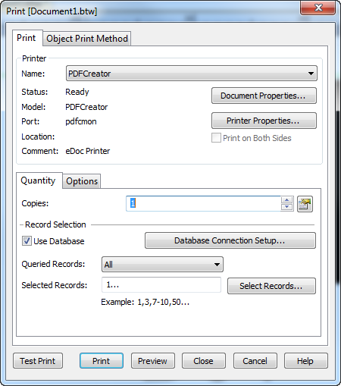

1. The labels will then print out on your label printer.

### Appendix A - Sample Labels

|  |  |
| --- | --- |
| **Shelf** |  |
| **Bin Part Labels** |  |
| **Rack** |  |
|  |  |